Configuration of Permanent
Magnet Electric Motor
 | 7.5kW Brushless DC Motor
NO. | Parmeters |  | Units | Amount | Remark
1 | Rated Power |  | kW | 7.5
2 | Peak Power |  | kW | 15 | Limiting the specific values of the secision by the controller
3 | Rated Voltage |  | V_{DC} | 96
4 | Rated Current |  | A | 87
5 | Rated Torque |  | Nm | 25.6
6 | Overload Torque |  | Nm | 51.2 | Limiting the specific values of the secision by the controller
7 | Rated Speed |  | Rpm | 2800
8 | Max. Speed |  | Rpm | 3500
9 | Anti-Electromotive |  | V/rad·s⁻¹ | 0.17
10 | Phase Current Average |  | A
11 | Working Type |  |  | 1h
12 | Protection Grade |  |  | IP55
13 | Insulation Level |  |  | F
14 | Cooling Mode |  |  | AIR
15 | Frame |  |  | Y132-B35
16 | Weight |  | Kg | 26
17 | Appearance
 | 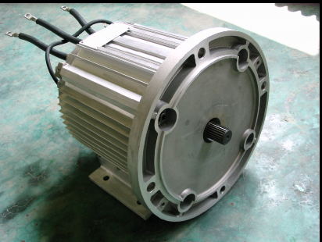 |  |  |  | Practical requirements of motor output shaft can be customized
18 | Size | Mm |  | Φ184×L297  MM
CONTROLLER SPECS. |  | BSC24-96
INPUT VOLTAGE RANGE 48-96 COOLONG TYPE AIR
MAX OUTPUT CURRENT 160A WORKING TEMPERATURE -20-60
KEEP TEMPERATURE -30-80 WEIGHT KG
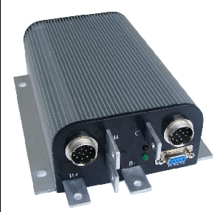 SIZE 200X146X62MM

PEDAL
INPUT VOLTAGE | 0.8--4.2V
CONTROL TYPE | POTENTIONMETER
